What is quantum Computing?
Quantum computing is an area of computer science that uses the principles of quantum theory. Quantum theory explains the behavior of energy and material on the atomic and subatomic levels.
Quantum computing uses subatomic particles, such as electrons or photons. Quantum bits, or qubits, allow these particles to exist in more than one state (i.e., 1 and 0) at the same time.
- The power of quantum computers grows exponentially with more qubits.
- Classical computers that add more bits can increase power only linearly.

Describe the Use of Quantum Computing.
Quantum computing could contribute greatly to the fields of security, finance, military affairs and intelligence, drug design and discovery, aerospace designing, utilities (nuclear fusion), polymer design, machine learning, artificial intelligence (AI), Big Data search, and digital manufacturing.
Quantum computers could be used to improve the secure sharing of information. Or to improve radars and their ability to detect missiles and aircraft. Another area where quantum computing is expected to help is the environment and keeping water clean with chemical sensors.4
Here are some potential benefits of quantum computing:5
- Financial institutions may be able to use quantum computing to design more effective and efficient investment portfolios for retail and institutional clients. They could focus on creating better trading simulators and improve fraud detection.
- The healthcare industry could use quantum computing to develop new drugs and genetically-targeted medical care. It could also power more advanced DNA research.
- For stronger online security, quantum computing can help design better data encryption and ways to use light signals to detect intruders in the system.
- Quantum computing can be used to design more efficient, safer aircraft and traffic planning systems.

Explain Qbit in Quantum Computing.
Just like a binary bit is the basic unit of information in classical (or traditional) computing, a qubit (or quantum bit) is the basic unit of information in quantum computing.
A qubit uses the quantum mechanical phenomena of superposition to achieve a linear combination of two states. A classical binary bit can only represent a single binary value, such as 0 or 1, meaning that it can only be in one of two possible states. A qubit, however, can represent a 0, a 1 or any proportion of 0 and 1 in superposition of both states, with a certain probability of being a 0 and a certain probability of being a 1.

Explain Superposition Principle in Quantum Computing with Example.
Superposition enables quantum algorithms to utilise other quantum mechanical phenomena, such as interference and entanglement. Together, superposition, interference and entanglement create computing power that can solve problems exponentially faster than classical computers.

Qubits can be in a superposition of both the basis states ∣0⟩∣0⟩ and ∣1⟩∣1⟩. When a qubit is measured (to be more precise: only observables can be measured), the qubit will collapse to one of its eigenstates and the measured value will reflect that state. For example, when a qubit is in a superposition state of equal weights, a measurement will make it collapse to one of its two basis states ∣0⟩∣0⟩ and ∣1⟩∣1⟩ with an equal probability of 50%. ∣0⟩∣0⟩ is the state that when measured, and therefore collapsed, will always give the result 0. Similarly, ∣1⟩∣1⟩ will always convert to 1.
Quantum superposition is fundamentally different from superposing classical waves. A quantum computer consisting of n qubits can exist in a superposition of 2^{n} states: from ∣000...0⟩to |111...1⟩. In contrast, playing n musical sounds with all different frequencies, can only give a superposition of n frequencies. Adding classical waves scales linear, where the superposition of quantum states is exponential.

Explain Entanglement in Quantum Computing with Example.
Quantum entanglement is the state where two systems are so strongly correlated that gaining information about one system will give immediate information about the other no matter how far apart these systems are. This phenomena baffled scientists like Einstein who called it “a spooky action at a distant” because it violates the rule saying that no information can be transmitted faster than the speed of light. However, further research validated entanglement using photons and electrons.

Quantum cryptography
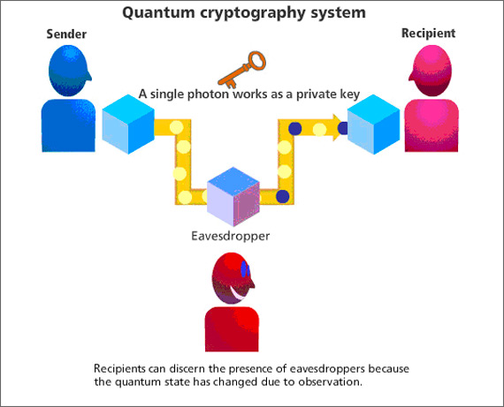
Cryptography is the process of exchanging information between two parties using an encrypted code and a deciphering key to decrypt the message.
The key to cryptography is to provide a secure channel between 2 parties. Entanglement enables that. If two systems are purely entangled that means they are correlated with each other (i.e. when one changes, the other also changes) and no third party shares this correlation. Additionally, quantum cryptography benefits from the no-cloning theorem which states that: “it is impossible to create an independent and identical copy of an arbitrary unknown quantum state”. Therefore, it is theoretically impossible to copy data encoded in a quantum state.

What is Reversible Gate? Explain its applications.
A logic gate is reversible if the mapping of inputs to outputs is bijective, that is, every distinct input yields a distinct output, and the number of output bits is equal to that of input ones and realizes a reversible function.A reversible gate with k input bits and k output bits is called a k × k reversible gate. A different set of reversible logic gates are used to build reversible circuits since traditional logic gates other than the NOT gate are not applicable in reversible logic. A reversible gate with n inputs and n outputs in an r-valued logic is represented by an r n x rn unitary matrix.
Reversible gates or reversible logic gates are the gates with a property of equal number of inputs and outputs, i.e. n- inputs and n-outputs. When the number of inputs and outputs are equal it will minimize energy loss during computations. This is possible because the outputs can be determined using the inputs and on the other hand equally the inputs can be recovered from the outputs, uniquely
Reversible computing may have applications in computer security and transaction processing, but the main long-term benefit will be felt very well in those areas which require high energy efficiency, speed and performance .it include the area like
1. Low power CMOS.
2. Quantum computer.
3. Nanotechnology
4. Optical computing
5. Design of low power arithmetic and data path for digital signal processing (DSP).
6. Field Programmable Gate Arrays (FPGAs) in CMOS technology for extremely low power, high testability and self-repair

Differentiating between Conventional Computing and Quantum Computing.
Classical Computer | Quantum Computer
It is large scale integrated multi-purpose computer. | It is high speed parallel computer based on quantum mechanics.
Information storage is bit based on voltage or charge etc. | Information storage is Quantum bit based on direction of an electron spin.
Information processing is carried out by logic gates e.g. NOT, AND, OR etc. | Information processing is carried out by Quantum logic gates.
Circuit behaviour is governed by classical physics. | Circuit behaviour is governed explicitly by quantum mechanics.
Classical computers use binary codes i.e. bits 0 or 1 to represent information. | Quantum computers use Qubits i.e. 0, 1 and both of them simultaneously to run machines faster.
Operations are defined by Boolean Algebra. | Operations are defined by linear algebra over Hilbert Space and can be represented by unitary matrices with complex elements.
No restrictions exist on copying or measuring signals | Severe restrictions exist on copying and measuring signals
Circuits are easily implemented in fast, scalable and macroscopic technologies such as CMOS. | Circuits must use microscopic technologies that are slow, fragile and not yet scalable e.g. NMR (Nuclear magnetic resonance).

How reversible gate can be represented?
A logic gate is reversible if the mapping of inputs to outputs is bijective, that is, every distinct input yields a distinct output, and the number of output bits is equal to that of input ones and realizes a reversible function.A reversible gate with k input bits and k output bits is called a k × k reversible gate. A different set of reversible logic gates are used to build reversible circuits since traditional logic gates other than the NOT gate are not applicable in reversible logic. A reversible gate with n inputs and n outputs in an r-valued logic is represented by an r n x rn unitary matrix.

What is Universal Reversible gate?
any classical reversible circuit can be constructed from universal reversible gates.
Example: Toffoli gate, Fredkin gate

Draw the Diagram of an Universal Reversible Gate with truth Table Represent that gate by Unitary Matrix.
….

Discuss the Motivation towards Quantum Computing.
Quantum computers outperform supercomputers in terms of efficiency because they use the power of quantum mechanics to perform calculations. China claimed in 2020 to have developed a quantum computer capable of performing computations 100 trillion times faster than any supercomputer. They can handle multiple tasks at once and can quickly solve complex problems that would take a supercomputer months to solve.

While traditional computers use bits to solve problems, quantum computers use qubits to run multidimensional quantum algorithms. Quantum computers outperform supercomputers in terms of speed and power. They can perform multiple computations at the same time, making them ideal for tackling complex problems requiring massive amounts of data to be processed quickly. Supercomputers can only work on one task at a time, but they can handle a wider range of tasks.

Discuss the features of Quantum Computing.

Superposition
…
Entanglement
…

Decoherence
Decoherence occurs when the quantum behavior of qubits decays. The quantum state can be disturbed instantly by vibrations or temperature changes. This can cause qubits to fall out of superposition and cause errors to appear in computing. It's important that qubits be protected from such interference by, for instance, supercooled refridgerators, insulation, and vacuum chambers.

Explain the Origin of Quantum Computing.
In 1980, Paul Benioff introduced the quantum Turing machine, which uses quantum theory to describe a simplified computer.
When digital computers became faster, physicists faced an exponential increase in overhead when simulating quantum dynamics, prompting Yuri Manin and Richard Feynman to independently suggest that hardware based on quantum phenomena might be more efficient for computer simulation.
In a 1984 paper, Charles Bennett and Gilles Brassard applied quantum theory to cryptography protocols and demonstrated that quantum key distribution could enhance information security.
Quantum algorithms then emerged for solving oracle problems, such as Deutsch's algorithm in 1985, the Bernstein–Vazirani algorithm in 1993, and Simon's algorithm in 1994. These algorithms did not solve practical problems, but demonstrated mathematically that one could gain more information by querying a black box with a quantum state in superposition, sometimes referred to as quantum parallelism.
Discuss Quantum Grover’s Algorithm.
Classically, searching an unsorted database requires a linear search, which is O(N) in time. Grover's algorithm, which takes O(N1/2) time, is the fastest possible quantum algorithm for searching an unsorted database. It provides "only" a quadratic speedup, unlike other quantum algorithms, which can provide exponential speedup over their classical counterparts.
Although the purpose of Grover's algorithm is usually described as "searching a database", it may be more accurate to describe it as "inverting a function". Roughly speaking, if we have a function y=f(x) that can be evaluated on a quantum computer, Grover's algorithm allows us to calculate x when given y. Inverting a function is related to the searching of a database because we could come up with a function that produces a particular value of y if x matches a desired entry in a database, and another value of y for other values of x.
let’s consider a situation where you have a list of unsorted numbers N as shown in the below diagram, where you want to find a value w (Red Box) from it that possesses some unique properties. So how could you find w?
fig.1 list on n numbers
Classical approach: In classical computing, we would have to check on average N/2 of these items in the list. In simple terms you would have to verify each of them one by one, In which you will require N steps i.e O(N). if random access and pre-sort are added to implement binary search on ordered data, it will require log(N) steps i.e O(log(N)). however, using a quantum algorithm will just roughly take √N steps i.e O(√N) for finding w, for instance, let's take a list of 25 elements and we want to search for a value from the list so classically it will take N steps and with the quantum algorithm, it will take √N steps i.e classically it will take 25 steps and quadratically it will take √25=5 steps.
It utilizes superposition and phase interference to improve the search. It’s the amplitude amplification that plays a very spatial role in searching the element we want. let’s visualize the amplitude amplification.
The amplitude amplification is a procedure that increases the probability amplitude of the value to be searched and decreased the rest of the probability amplitudes
consider the below Kets (k1, k2, k3,…..kn) in a balanced superposition, we want to hunt kw so by performing amplitude amplification we and when the kets are sent for amplification process, the first oracle flips the kw ket upside down to negative phase from the probability of .0 to -.5 which separates it from other kets.
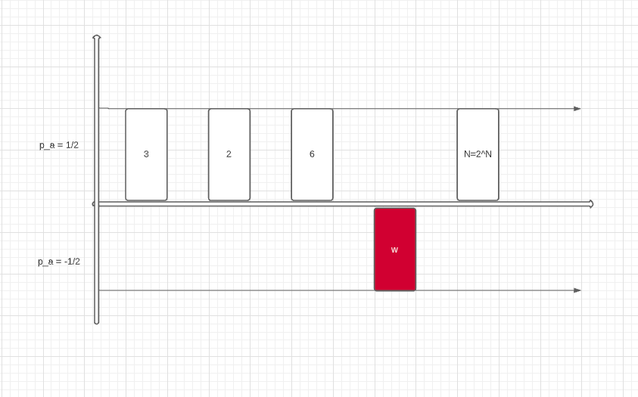
fig.2 Oracle
The second oracle inverts all the amplitude by calculating its mean i.e the average. This leads to a decrease in the amplitude A∉ kw. And increases the kw ket such that the kw becomes 1 and the rest of the kets becomes 0
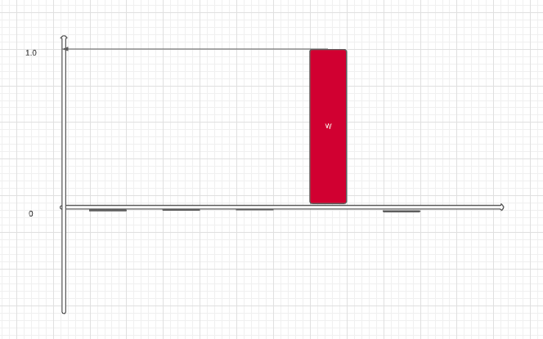
fig.3 Diffuser
At the final stage, the states from the second oracle are measured with encoded values relating to the item in the list. And it maps the resulting state back to the database. If the answer is incorrect the steps are repeated. the error probability is O(1/N).
- Here you can assume oracle and diffuser are simply two black boxes that perform certain operations on the qubits.
Firstly, oracle is denoted as Uf and the second one as Uφ, which is Grover’s diffusion operator. These oracles are repeated √N times. If the matches are multiple m, then the oracles are repeated √(N/t) times. Grover search can also be used to search multiple elements.
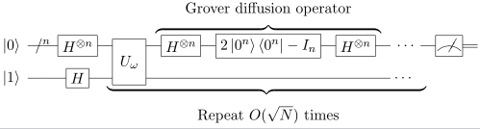
fig.4 Grover’s algorithm circuit [source]
The above figure is Grover’s algorithm circuit that follows the below algorithm.
Let’s take a quick look over Grover’s Quantum algorithm
The algorithm is summarized as follows:
- Pick a random value you wanna search from the qubits.
- Put all the qubits to superposition by passing it to Hadamard gate H.
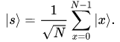
- Construct oracle f that flips the amplitude of the object to be searched.
- Construct the Diffuser that inverts around the mean.
- Repeat the oracle √N times for a single target and √(N/t) for multiple targets.
- finally, validate the states with the values in the database.
- And take a sip of coffee. you’re done.
- Superposition is the ability of a quantum system to be in multiple states at the same time
Note: If you increase the iterations the performance decreases.

What is Fault Model in Quantum Reversible Circuits? Discuss Stuck-at-faults model and Crosspoint fault models with diagram.
Fault is an error occurred in the system by which system deviates from its normal operation. Fault models simplify complexity of testing by reducing number of faults that have to be considered.
Stuck-at Fault Model
The stuck-at fault [15] of a logic gate causes one of its inputs and outputs to be fixed at either 0 (stuck-at-0) or 1 (stuck-at-1) without considering the input value. This is a very common fault model used for irreversible circuits. According to [16] the stuck-at fault model can be used for the next generation technologies. For example we have a reversible circuit shown in Figure 2.15. A stuck-at-1 on first output of the first gate gives value 1 to output O1 without going for considering the input value. Patel et al. [132] shows testing of all single and multiple stuck-at faults occurred in a reversible circuit.
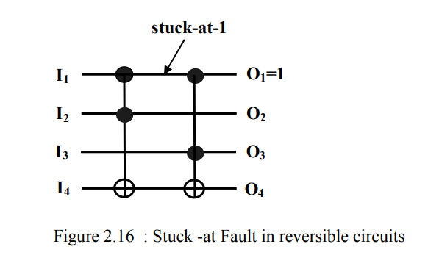
Zhong J.[133] et al. shown that the stuck-at fault model, on its own, is inadequate for modeling the behavior of different faults in reversible circuits. They introduce a new type of fault model, labeled the cross point fault model.
Cross point Faults
A crosspoint fault in a reversible logic circuit is defined as either an extra or a missing control point in a generalized Toffoli gate. It is classified into two categories: disappearance faults and appearance faults. A disappearance fault happens when a control point in a Toffoli gate missing. For example, consider the structure of the full adder shown in Figure 2.17(a), in the first Toffoli gate a disappearance fault happens if the control point from line b is missing. This fault changes the Toffoli gate into a CNOT gate. It transpires that this disappearance fault model is the same as the partial missing-gate fault model introduced in [131].
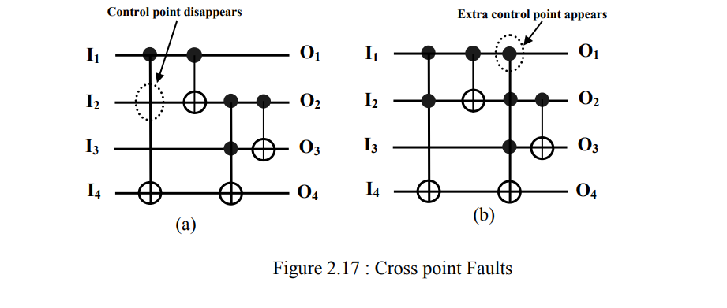
Similarly, an appearance fault happens when an extra control point is introduced to a Toffoli gate. For instance, consider the same fuller adder in Figure 2.17(b), a possible appearance fault can be adding one additional control point from line a to the third gate. This appearance fault results in transforming the 2-input Toffoli gate into a 3-input Toffoli gate. Multiple crosspoint faults are defined as situations where two of more single crosspoint faults exist in a reversible circuit at the same time. They are categorized into three types: multiple disappearance faults, multiple appearance faults, and mixed multiple faults. A multiple disappearance fault happens when at least two control points disappear from the circuit at the same time. Similarly, a multiple appearance fault means that two or more extra control points are added to the circuit. And a mixed multiple cross point fault happens when both appearance fault and disappearance fault exist in a reversible circuit at the same time. The cross point fault model is suitable for describing the faults that can happen on the control points of generalized Toffoli gates, but it is also suitable for other reversible logic gates with control points such as the Fredkin gates.

Explain Bridging Fault Model in Reversible Circuit.
A test generation problem of reversible circuits are simpler than that of classical circuit due to inherent ease of controllability and observability [94] and always yields an unique vector at the input. Bridging faults are caused by shorts between two (or more) lines. Logically all the lines are involved in a bridging fault may be classical AND-OR type. A bridging fault is activated by input vector t, if the two lines are assigned opposite logic values (‘01’ or ‘10’) then the error can be propagate to the output of the reversible circuit. Since a reversible circuit is bijective, fault free output is different from faulty output of a reversible circuit. A a b c d a d a⊕b a b c d a b⊕c ( b⊕c ) ⊕ d a⊕b single input bridging fault (SIBF) is a bridging fault, involving two input lines at a time of a circuit. A multiple input-bridging fault (MIBF) is a bridging fault involving more than two input lines at a time of a circuit. An intra level bridging fault (ILBF) is a bridging faults involving two or more intra lines into the any level of the circuit.

What is Redundancy in Reversible Circuit? Explain it.
Traditionally, redundancy in circuit design has been closely tied to testability. A combinational circuit that contains an undetectable stuck-at fault is said to be redundant, since such a circuit can always be simplified by removing at least one gate or gate input [17, page 100]. While the presence of redundancy in digital designs may often be intentional, as in fault tolerant systems, or for hazard avoidance, it is obvious that one would normally wish for a synthesis algorithm to avoid the inclusion of unnecessary redundant elements. For our purposes, a reversible logic circuit is said to be redundant if it contains a gate, or a line (an input-output pair in a reversible logic gate), which can be removed without affecting the logical output of the circuit.
So, if one reversible logic circuit is redundant, we can remove at least one gate or gate input-output pair from the circuit in order to reduce cost. The Figure 2.21(a) denotes a situations where at least one gate could be removed from the circuit, or replacing a network with one of fewer gates, such as consecutive duplicated gates. This is one type of redundancy.

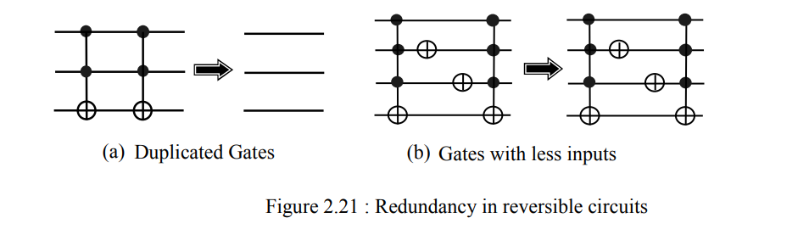
What is Bit and What is Quantum Bit(Qbit)? What is the difference between these?
Ans:
Bit:
A bit (binary digit) is the smallest unit of data that a computer can process.
Qbit:
Just like a binary bit is the basic unit of information in classical (or traditional) computing, a qubit (or quantum bit) is the basic unit of information in quantum computing. A qubit uses the quantum mechanical phenomena of superposition to achieve a linear combination of two states.
Difference between bits and Qbits:
Qubits | Bits
Any cryptographic or huge computational tasks can be perfected with the help of qubits through quantum computing. | Though computational and cryptographic tasks can be done in traditional computing, the perfection level in cryptography will not be accurate as qubits.
The complex amplitudes of wind for weather and to notify the scaling in the global positioning system is the application in quantum computing. Also, with the help of superposition, various methods can be tried for all the probabilities in the technology. | Traditional computing is marked with probabilities. This helps to check the stock price in the business or weather forecasting in a system or monitor various security levels on the border.
Qubits are represented with the quantum state’s help, and the values are called amplitudes, which is the superposition of binary values. | The vector to represent the bits is the probability vector, and the values in the vector are zero and one. Here both the values cannot be null, and it represents the current state in the vector.
The values in qubits are measured when it is moved around a sphere, and this helps to consider all the values in the system. | The values are taken only at two states, and it is considered as 0 and 1. While considering the sphere, the value will be taken from the top and bottom.
The measurement is taken in the form of a global phase and a relative phase, where the relative phase matters the most for the measurement of quantum systems. The global phase is mostly ignored. | The measurement is taken only in the form of the relative phase, and this takes the normal values in the system. The values are not complex and can be understood by anyone.
While discussing qubits, we can say that the values depend on quantum computing, computers, and mathematics with logical programming applied. | Bits consider only computers and math with logical computing. This makes the process simpler with fewer calculations and less speed comparatively with qubits.
All the physical measurements can be done with qubits’ help, which helps the researchers and physicists do the research faster than done in traditional computing. | Physical calculations are not easy to be done on normal computers, and also it will take a long time to complete the calculations and formulate results.

Write Short note on the following. Quantum Shor’s Algorithm
Shor's algorithm is a quantum computer algorithm for finding the prime factors of an integer. It was developed in 1994 by the American mathematician Peter Shor.
On a quantum computer, to factor an integer N, Shor's algorithm runs in polylogarithmic time, meaning the time taken is polynomial in log N.

Specifically, it takes quantum gates of order O((logN)²(loglogN)(logloglogN)) using fast multiplication. O(log N) space.
Shor's algorithm consists of two parts:
The algorithm is composed of two parts. The first part of the algorithm turns the factoring problem into the problem of finding the period of a function, and may be implemented classically. The second part finds the period using the quantum Fourier transform, and is responsible for the quantum speedup.

I. Obtaining factors from period
- The integers less than N and coprime with N form a finite group under multiplication modulo N, which is typically denoted (Z/NZ)×. By the end of step 3, we have an integer a in this group. Since the group is finite, a must have a finite order r, the smallest positive integer such that
- a^{r} ≡ 1 mod N.
- Therefore, N | (a r − 1). Suppose we are able to obtain r, and it is even. Then
- a^{r} − 1 = (a^{r/2} − 1)(a^{r/2} + 1) ≡ 0 mod N
- ⇒ N ∣(a^{r/2} − 1)(a^{r/2} + 1).
- r is the smallest positive integer such that a r ≡ 1, so N cannot divide (a r / 2 − 1). If N also does not divide (a r / 2 + 1), then N must have a nontrivial common factor with each of (a r / 2 − 1) and (a r / 2 + 1).
- Proof: For simplicity, denote (a r / 2 − 1) and (a r / 2 + 1) by u and v respectively. N | uv, so kN = uv for some integer k. Suppose gcd(u, N) = 1; then mu + nN = 1 for some integers m and n (this is a property of the greatest common divisor.) Multiplying both sides by v, we find that mkN + nvN = v, so N | v. By contradiction, gcd(u, N) ≠ 1. By a similar argument, gcd(v, N) ≠ 1.
- This supplies us with a factorization of N. If N is the product of two primes, this is the only possible factorization.

II. Finding the period
- Shor's period-finding algorithm relies heavily on the ability of a quantum computer to be in many states simultaneously. Physicists call this behaviour a "superposition" of states. To compute the period of a function f, we evaluate the function at all points simultaneously.
- Quantum physics does not allow us to access all this information directly, though. A measurement will yield only one of all possible values, destroying all others. Therefore we have to carefully transform the superposition to another state that will return the correct answer with high probability. This is achieved by the quantum Fourier transform.
- Shor thus had to solve three "implementation" problems. All of them had to be implemented "fast", which means that they can be implemented with a number of quantum gates that is polynomial in logN.

Write Short note on the following. Missing Gate Fault
Single missing-gate fault (SMGF)
A single missing-gate fault (SMGF) corresponds to the missing-gate fault discussed in [136]. It is defined as a complete disappearance of one CNOT gate from the circuit. The physical justification for a SMGF is that the pulse(s) implementing the gate operation is (are) short, missing, misaligned or mistuned.
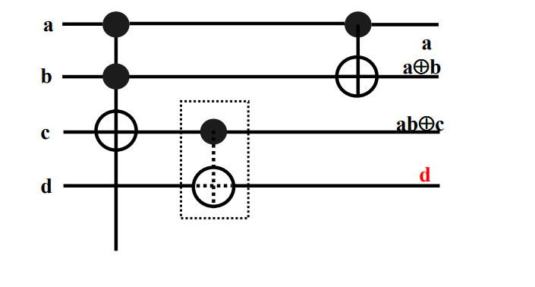
Figure 2.18 shows an SMGF marked by the dotted box in the reversible circuit, where the 2nd gate is missing. The number of possible SMGFs is equal to the number of gates in the circuit.

Multiple missing-gate faults (MMGF)
In this model, it is assumed that several consecutive gates are completely removed from the circuit. In the circuit of Figure 2.18, it is shown that the circuit has an MMGF marked by the dotted box. In contrast to traditional definition of multiple faults, MMGF is not necessarily the same as multiple SMGF. In this model, all of the missed gates must be consecutive gates, while multiple SMGF implies that several distinct arbitrary gates are missed which are not necessarily consecutive [136]. In [136]
An example involving two missing gates is shown in Figure 2.19.
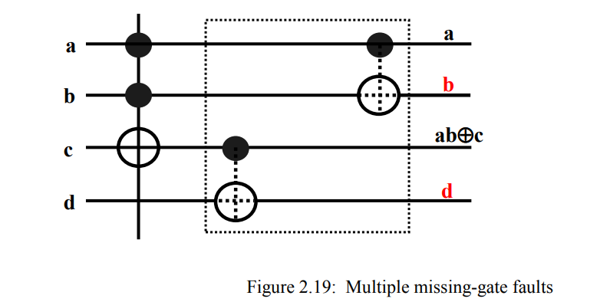
Repeated-gate fault (RGF)
In this fault, a gate is replaced by several instances of the same gate.
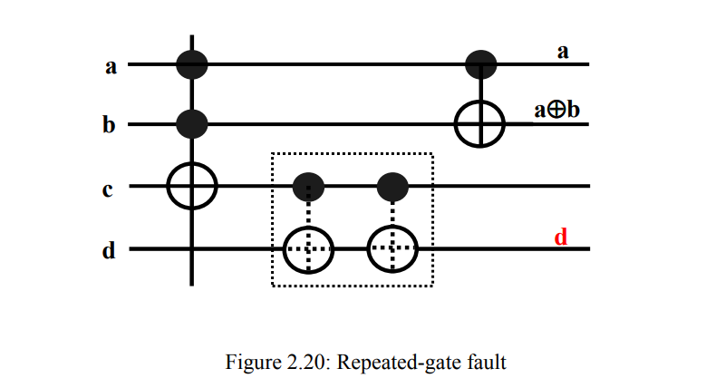
Partial missing-gate fault (PMGF)
This fault, also known as a disappearance fault, assumes a subset of control inputs of a gate is removed.
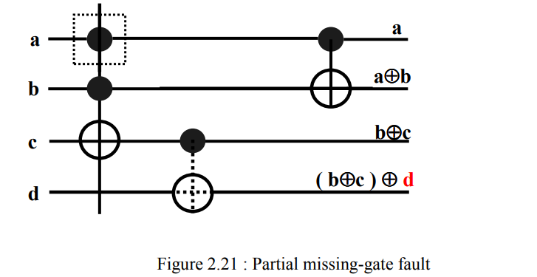

Write Short note on the following. Quantum Error Correction
“Noise” describes all of the things that cause interference in a quantum computer. Just like a mobile phone call can suffer interference leading it to break up, a quantum computer is susceptible to interference from all sorts of sources, like electromagnetic signals coming from WiFi or disturbances in the Earth’s magnetic field. When qubits in a quantum computer are exposed to this kind of noise, the information in them gets degraded just the way sound quality is degraded by interference on a call. This is known as decoherence.
In QEC quantum information stored in a single qubit is distributed across other supporting qubits; we say that this information is "encoded" in a logical quantum bit. This procedure protects the integrity of the original quantum information even while the quantum processor runs - but at a cost in terms of how many qubits are required. Overall, the worse your noise is, the more qubits you need.
Depending on the nature of the hardware and the type of algorithm you choose to run, the ratio between the number of physical qubits you need to support a single logical qubit varies - but current estimates put it at about 1000 to one. That's huge. Today’s machines are nowhere near capable of getting benefits from this kind of Quantum Error Correction.
QEC has seen many partial demonstrations in laboratories around the world - first steps making clear it’s a viable approach. But in general the enormous resource overhead leads to things getting worse when we try to implement QEC. Right now there is a global research effort underway trying to cross the “break even” point where it’s actually advantageous to use QEC relative to the many resources it consumes.

