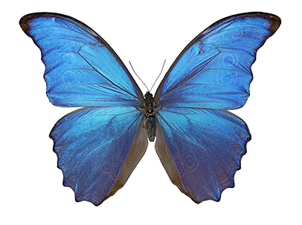  Butterflies are not very filling. Unless you are a small bird. | The blue Morpho butterfly is indigeous to South and Central Mexico. The largest of the genus morpho has a wingspan of 8 inches. The butterfly feeds on the juices of fermetting fruit. The blue butterfly is now raise in commercial breeding programs.
The tiger is largest of the four “big cats.” Of the nine subspecies of tiger, three are extinct, and the remaining six are classified as endangered. Male tigers require a territory of 60 to 100 square kilometers, females about 20 square kilometers.
2010 is the Year of the Tiger

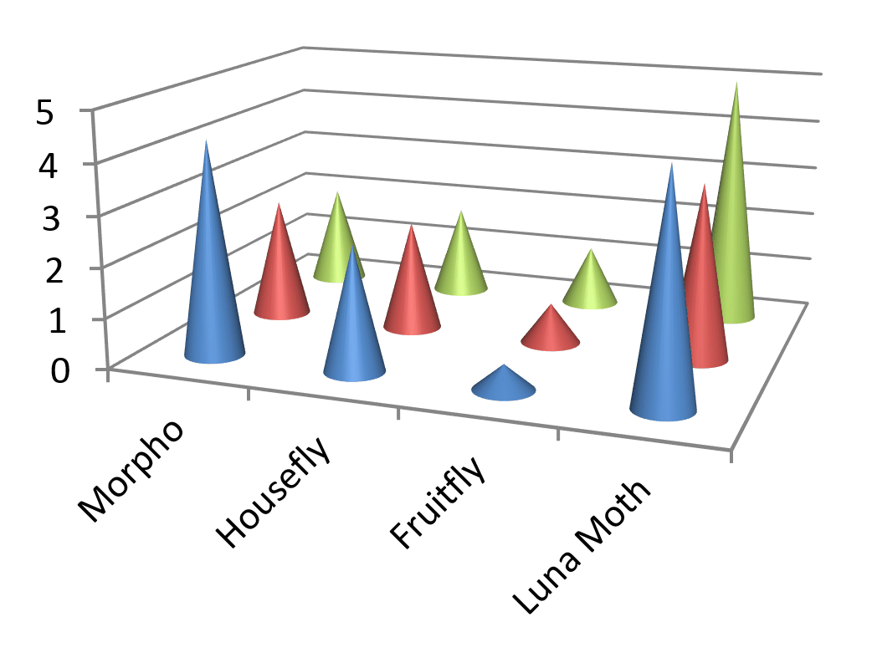 | Figure 1: Estimated Calories per Bug

